Contents
Sl. No. | Particular | Page No
 | Instructions for Filling the Format | 2
 | Summary of achievements during the reporting period | 4
1 | General Information | 6
2 | On Farm Testing | 9
3 | Achievements of Frontline Demonstrations | 13
4 | Documentation of the need assessment conducted by the KVK for the training programme | 21
5 | Training programmes | 22
6 | Extension Activities | 28
7 | Literature Developed/Published (with full title, author & reference) | 29
8 | Production and supply of Technological products | 30
9 | Activities of Soil and Water Testing Laboratory | 31
10 | Rainwater Harvesting | 31
11 | Utilization of Farmer Hostel facilities | 31
12 | Utilization of Staff Quarter facilities | 31
13 | Details of SAC Meeting | 32
14 | Status of Kisan Mobile Advisory | 32
15 | Status of Convergence with agricultural schemes | 32
16. | Status of Revolving Funds | 33
17. | Awards & Recognition | 33
18. | Case study and Success story | 33
19. | Details of KVK Agro-technological Park | 33
20. | Important visitors to KVK | 33
21. | Status of KVK Website | 34
22. | Status of E-connectivity | 34
23. | Details of Technological Week Celebration | 34
24. | Interventions on Drought Mitigation | 35
25. | Status of KVK Website | 36
26. | Action Photographs | 36
Instructions for Filling the Format

- Do not change/modify/ delete any column of any of the table. However, additional rows can be created, if required
- Do not merge columns, rows.
- Please repeat the name of KVK in each table in the column “Name of KVK”
- Do not fill the non-numerical values in numeric field
- Do not repeat the unit while reporting data as it is already mentioned in the heading row
- Strictly fill the data in desired unit only. If it is reported in other unit, convert it in the desired unit
- Please mention only standard English names of crops (Do not mention Urd, Arhar, Til, Kulthi, Moong, Bajra, etc.)
- Additional relevant information may be provided at the end of Format by creating heading “Additional Information”
- Also read the instructions mentioned just below the table
- Your suggestions for improvement in the format for your simplicity as well as data compilation may be given at the end of the format
- Do not press any Enter Key in any of the columns while making entry in the columns of the table. Use only arrow key /Tab key/ mouse pointer while movement from one column/row to another.
- Gray colour cells in summary table need not to be filled.
- Do not change/modify/ delete any column of any of the table. However, additional rows can be created, if required
- Do not merge columns, rows.
- Please repeat the name of KVK in each table in the column “Name of KVK”
- Do not fill the non-numerical values in numeric field
- Do not repeat the unit while reporting data as it is already mentioned in the heading row
- Strictly fill the data in desired unit only. If it is reported in other unit, convert it in the desired unit
- Please mention only standard English names of crops (Do not mention Urd, Arhar, Til, Kulthi, Moong, Bajra, etc.)
- Additional relevant information may be provided at the end of Format by creating heading “Additional Information”
- Also read the instructions mentioned just below the table
- Your suggestions for improvement in the format for your simplicity as well as data compilation may be given at the end of the format
- Do not press any Enter Key in any of the columns while making entry in the columns of the table. Use only arrow key /Tab key/ mouse pointer while movement from one column/row to another.
- Gray colour cells in summary table need not to be filled.

REPORTING PERIOD – April 2011 to March, 2012

Summary of achievements during the reporting period
KVK Name | Activity | Target |  | Achievement
KVK Name | Activity | Number of activity | No. of farmers/ beneficiaries | Number of activity | No. of farmers/ beneficiaries | Total value of resource generated/Fund received from diff. sources (Rs.)
Balasore | OFTs | 22 | 140 | 16 | 110
Balasore | FLDs – Oilseeds (activity in ha) | 5 | 20 | 1 | 20
Balasore | FLDs – Pulses (activity in ha) | 5 | 20 | 1 | 20
Balasore | FLDs – Cotton (activity in ha) | 0 | 0 | 0 | 0
Balasore | FLDs – Other than Oilseed and pulse crops(activity in ha) | 19 | 190 | 15 | 153
Balasore | FLDs – Other than Crops (activity in no. of Unit/Enterprise) | 5 | 45 | 4 | 40
Balasore | Training-Farmers and farm women | 75 | 1875 | 74 | 1850
Balasore | Training-Rural youths | 15 | 225 | 13 | 195
Balasore | Training- Extension functionaries | 15 | 225 | 7 | 105
Balasore | Extension Activities | 500 | 10000 | 843 | 12934
Balasore | Seed Production (Number of activity as seeds in quintal) | 15 | 30 | 16.45 | 56 | 44764
Balasore | Planting material (Number of activity as quantity of planting material in quintal)
Balasore | Seedling Production (Number of activity as number of seedlings in numbers) | 80000 | 500 | 7500 | 340 | 1500
Balasore | Sapling Production (Number of activity as number of sapling in numbers) | 5000 | 500 | 3000 | 210 | 5000
Balasore | Other Bio- products-vermi compost(q) | 10 | 50 | 12.44 | 72 | 5270
Balasore | Live stock products | 5000 | 500 | 1390 | 120 | 55628
Balasore | SAC Meeting (Date & no. of core/official members |  |  | 08.07.2011 | 28
Balasore | Newsletters (no.) | 4 | 2000 | 4 | 2000
Balasore | Publication (Research papers, popular article) | 12 |  | 16
Balasore | Convergence programmes / Sponsored programmes |  |  | 1 | 50
Balasore | KVK-ATMA Linkage programme (Number of activities)
Balasore | Outreach of KVK in the District (No. of blocks, no. of villages) |  |  | 8 | 135
Balasore | Soil sample tested | 1000 | - | 986 | 986 | 3840
Balasore | Water sample tested | - | - | 69 | 69 | -
Balasore | KMA (No. of messages & beneficiaries) | - | - | 67 | 430

1. GENERAL INFORMATION
1.1. Staff Position (as on 01.04.2012)

Name of KVK. | Sanctioned post | Name of the  incumbent | Discipline | Highest degree | Subject of  specialization | Pay Scale (Rs.) | Present basic (Rs.) | Date of joining | Permanent  /Temporary | Category (SC/ST/  OBC/  Others)
Balasore | Programme Coordinator | R. S. Panigrahi | Ag. Extn | MSc(Ag) | Ag. Extension |  |  | 25.08.2009 | Permanent | Others
Balasore | Subject Matter Specialist1 | A. C. Dash | Crop Production | MSc(Ag) | Agronomy | 15600-39100 +GP 6000 | 16250 | 20.11.2009 | Temporary | -do-
Balasore | Subject Matter Specialist2 | Dr. D. Dash | Soil Science | Ph.D. | Soil science | -do- | -do- | 30.10.2009 | Temporary | -do-
Balasore | Subject Matter Specialist3 | B. Sahoo | Horticulture | MSc (Ag) | Horticulture | -do- | 18320 | 22.08.2010 | Permanent | -do-
Balasore | Subject Matter Specialist4 | S. N. Mishra | Plant Protection | MSc (Ag) | Entomology | -do- | 15600 | 26.04.2010 | Temporary | -do-
Balasore | Subject Matter Specialist5 | R. K. Kar | Forestry | M.Sc. (Agroforestry) | Agroforestry | -do- | 19050 | 23.12.2008 | Permanent | -do-
Balasore | Subject Matter Specialist6 | Mrs.A.R.Patra | H. Science | MSc(Ag) | Home Science | -do- | 16250 | 30.10.2009 | Temporary | -do-
Balasore | Programme Assistant | M. C. Moharana | Fishery | BFSc. | Fishery | 1,640 – 2,900  (Pre-revised) | 2600 | 23.03.1998 | Temporary | -do-
Balasore | Farm Manager | K. M. Biswal | - | B.Sc. | - | 9300-34800 | 13910 | 09.11.2001 | Permanent | -do-
Balasore | Computer Programmer | G. K. Ojha | Computer | PGDCA | - | 9300-34800 | 12750 | 13.05.2005 | Permanent | -do-
Balasore | Accountant / superintendent | - | - | - | - | - | - | - | - | Vacant
Balasore | Stenographer | - | -- | - | - | - | - | - | - | Vacant
Balasore | Driver | S. K. Das | - | - | - | 3050-4590 | 3125 | 23.07.2008 | - | Others
Balasore | Driver | M. A. Khan | - | - | - | -do- | -do- | 04.04.2011 | - | -
Balasore | Supporting staff | D. N. Das | - | - | - | 2500-3200 | 2605 | 01.08.2008 | - | Others
Balasore | Supporting staff | R. K. Mohaptra | - | - | - | -do- | 2715 | 01.08.2008 | - | Others

1.2. DISTRICT PROFILE (detail of geographical area, cultivation, Land, resources, opportunities, irrigation, populations etc.)–

Total geographical area : 3, 77,400 ha
Cultivated Area : 2, 50, 550 ha
Land Marginal : 56224 ha
Small : 75135 ha
Semi Medium : 66019 ha
Medium : 37597 ha
Large : 7502 ha
Irrigation :158075 ha
Populations : 20,23,056

1.3. DETAILS OF ADOPTED VILLAGE during the reporting period (Approved by competent Authority in meetings/workshops)
KVK Name | Village Name | Year of adoption | Block Name | Distance from KVK | Population | Number of farmers (having land in the village)
Balasore | Paradipa | 2009-10 | Baliapal | 8 | 720 | 88
Balasore | Aruadam | 2009-10 | Baliapal | 16 | 450 | 78
Balasore | Kalidiha | 2009-10 | Basta | 18 | 550 | 62
Balasore | Nuagaon | 2009-10 | Remuna | 65 | 315 | 55
Balasore | Sekhsorai | 2009-10 | Jaleswar | 50 | 650 | 114

1.4. THRUST AREAS identified by KVK (Approved by competent Authority in meetings/workshop)
KVK Name | THRUST AREA
Balasore | Varietal substitution and improved package of practices in Paddy, Jute, Sugarcane, Oilseeds & Pulses.
Balasore | Increase in area under vegetables & emphasis on fruit cultivation. Standardizing package of practices for plantation crops like Betelvine, Cashew nut & Coconut.
Balasore | Increase in arable area through the promotion of Agro-forestry in waste lands.
Balasore | Suitable package of practices for problem soils like acidity, alkalinity & flood prone regions with emphasis on green manuring & composting.
Balasore | Technology assessment & refreshment on major diseases & pests of field crops & horticultural crops with emphasis on biocontrol and organic farming.
Balasore | Promotion of pisciculture, backyard poultry, mushroom cultivation, apiculture, lac cultivation & floriculture etc. for livelihood generation of vulnerable sections like marginal farmers, landless labours, farm women as well as SC/ST community.
Balasore | Emphasis on youth Agro-entrepreneurship, women in agriculture,integrated farming system and post harvest processing cum value addition.
Balasore | Programme liasioning with the District Agricultural Department and coordinating agro-tech data base of the district.

1.4. PROBLEM IDENTIFIED by KVK (Approved by competent Authority in meetings/workshop)

KVK Name | Problem identified | Methods of problem identification
Balasore | Low yield in vegetables, adoption of local varieties of rice with less market demand | PRA Survey And Group Discussion
Balasore | Severe disease incidence and improper nutrient application in Pana Baraj, non adoption of additional income sources like poultry, goatery by the low income families | PRA Survey And Group Discussion
Balasore | Adoption of local varieties of rice with less market demand, low yield of greengram due to YMV susceptible local varieties, low yield of fish | PRA Survey And Group Discussion
Balasore | Absence of high value vegetables, indiscriminate use of chemical pesticides & fertilizers | PRA Survey And Group Discussion
Balasore | Low yield in vegetables, low yield in fish, lack of exposure for freshwater prawn culture | PRA Survey And Group Discussion
Balasore | Indiscriminate use of chemical fertilizers & low usage of organic matter | PRA Survey And Group Discussion

2. On Farm Testing
1 Information about OFT
KVK name | Year/  season | Problem diagnose | Category of technology (Assessment/ Refinement) | Thematic Area | Crop/ enterprise | Farming Situations | Title of OFT | No. of trials | Results (Yield q/ha) |  | Net Returns (Rs./ha) |  | Recommendations
 |  |  |  |  |  |  |  |  | Farmer practice T1 | Rec. Tech  T2 | T1 | T2 | Recommendations
Balasore | Kharif, 2011 | High cost of cultivation due to manual weeding | Assessment | Integrated weed management | Jute | Rainfed | Assessment of Quizalofop-p-ethyl for controlling weeds in jute | 10 | 22.8 | 25.5 | 13980 | 22800 | Application of herbicide reduced the labour cost significantly and increased jute yield
Balasore | Kharif, 2011 | Low yield of paddy from existing cultivars | Assessment | Varietal evaluation | Rice | Irrigated | Assessment of hybrid rice Ajay | 5 | 50.6 | 62.0 | 23725 | 32500 | Ajay resulted in significantly higher yield than existing variety Lalat
Balasore | Rabi, 2011-12 | Low yield due to micronutrient deficiency | Assessment | INM | Rice | Irrigated | Assessment of B and Zn in rice | 5 | Contd.
Balasore | Rabi, 2011-12 | High cost of cultivation due to manual weeding | Assessment | Integrated weed management | Green gram | Irrigated | Assessment of Imazethapyr for controlling weeds in greengram | 5 | Contd.
Balasore | Kharif, 2011 | Low yield of pumpkin due to more borne of more number of male flowers and fruit drop | Assessment | ICM | Pumpkin | Irrigated | Assessment of hormone (Ethrel) for manupulating sex  expression in pumpkin | 5 | 277.74 | 362.65 | 46372 | 68555 | Foliar application of ethrel significantly increased fruit retention and yield
Balasore | Rabi, 2011-12 | High cost of cultivation due to manual weeding | Assessment | Integrated weed management | Onion | Irrigated | Assessment of Oxyflurfen for conrolling weeds in onion | 5 | Result awaited
Balasore | Rabi, 2011-12 | Low yield due to nutrient deficiency and imbalance fertilizer application | Assessment |  | Lady’s finger | Irrigated | Assessment of vermiwash in Okra | 5 | Result awaited
Balasore | Kharif, 2011 | Low yield in paddy due to sheeth rot | Assessment | IDM | Paddy | Rainfed | Assessment of propiconazole & validamycin for controlling sheath rot in Kharif rice | 10 | 48.6 | 53.8 | 24800 | 29600 | Alternate spraying of propiconazole & validamycin for successful management of sheeth rot.
Balasore | Kharif, 2011 | Low yield in paddy due to BPH | Assessment | IPM | Paddy | Rained | Assessment of buprofezin & thiomethoxam for management of BPH in rice | 10 | 48.7 | 53.6 | 24900 | 29400 | Alternate spraying of buprofezin & thiomethoxam for successful management of BPH
Balasore | Rabi 2011-12 | Low yield in brinjal due to fruit and shoot borer. | Assessment | IPM | Brinjal | Irrigated | Assessment of Thiacloprid for management of fruit and shoot borer in brinjal | 5 | Result awaited.
Balasore | Kharif, 2011 | Low yield due to disease infestation | Assessment | Production and management | Fish | Rainfed | Assessment of efficacy of probiotics in fish yield | 5 | Result awaited.
Balasore | Kharif 2011 | Low yield due to traditional Tassar rearing | Assessment | Production technology | Tassar | Rainfed | Assessment of Chawki Silk worm rearing | 10 | 25600 | 28800 | 11200 | 14100 | Chawki method of rearing increases quality and no of cocoons.
Balasore | Rabi, 2011-12 | Low stick yield due to nutrient deficiency | Assessment | ICM | Ikad | Irrigated | Assessment of nutrient management in Ikad | 10 | Result awaited
Balasore | Kharif, 2011 | Low mushroom yield due to low biological efficiency of PSM | Assessment | Mushroom cultivation | Milk mushroom | Rainfed | Assessment of milk mushroom production | 10 | 1.100 | 1.250 | 42.00 | 62.50 | Milk mushroom gave 150g more yield/bed over PSM. It has enhanced shelf life responding to extended transit for market
Balasore | Rabi, 2011-12 | High drudgery | Assessment | Drudgery reduction | Jute | Rainfed | Assessment of Jute stripper
Balasore | Rabi, 2011-12 | Non availability green fodder (grass) during lean period | Assessment | Fodder managementt | Oat | Rainfed | Assessment of Oat as fodder crop | Result awaited

Economic Performance
KVK name | OFT Title | Parameters |  |  | Average Cost of cultivation (Rs/ha) |  |  | Average Gross Return (Rs/ha) |  |  | Average Net Return (Rs/ha) |  |  | Benefit-Cost Ratio (Gross Return / Gross Cost)
KVK name | OFT Title | Name and unit of Parameter | Demo | Check | FP (T₁) | RP (T₂) | Refined Practice, if any (T₃) | FP (T₁) | RP (T₂) | Refined Practice, if any (T₃) | FP (T₁) | RP (T₂) | Refined Practice, if any (T₃) | FP (T₁) | RP (T₂) | Refined Practice, if any (T₃)
Balasore | Assessment of Quizalofop-p-ethyl in jute | Mandays, No | 50 | 20 | 22500 | 18000 |  | 36480 | 40800 |  | 13980 | 22800 |  | 1.62 | 2.27
Balasore | Assessment of hybrid rice Ajay | No of effective tillers/ | 22 | 14 | 26875 | 29500 |  | 50600 | 62000 |  | 23725 | 32500 |  | 1.88 | 2.10
Balasore | Assessment of B and Zn in rice | Chaffy grain, %
Balasore | Assessment of Imazethapyr for controlling weeds in greengram | Mandays, No
Balasore | Assessment of hormone (Ethrel) for manupulating sex expression in pumpkin | No. of fruit/vine | 6 | 3 | 36960 | 40240 |  | 83332 | 108795 |  | 46372 | 68555 |  | 2.25 | 2.70
Balasore | Assessment of Oxyflurfen for conrolling weeds in onion | Mandays, No
Balasore | Assessment of vermiwash in Okra | Plant height, cm
Balasore | Assessment of propiconazole & validamycin for controlling sheath rot in Kharif rice | Infestation percentage | 06% | 18% | 23,800 | 24,400 |  | 48600 | 53800 |  | 24,800 | 29,600 |  | 2.04 | 2.2
Balasore | Assessment of buprofezin & thiomethoxam for management of BPH in rice | No of adult insects/hill | 02 | 25 | 23,800 | 24,200 |  | 48700 | 56600 |  | 24,900 | 29,400 |  | 2.04 | 2.33
Balasore | Assessment of thiacloprid for management of fruit and shoot borer in brinjal | Infestation percentage
Balasore | Assessment of efficacy of probiotics in fish yield | Growth rate | 327 | 197
Balasore | Assessment of Chawki Silk worm rearing | Cocoon /tree | 72 | 64 | 24000 | 25500 |  | 35200 | 39600 |  | 11200 | 14100 |  | 1.47 | 1.55
Balasore | Assessment of nutrient management in Ikad | Stick height, m
Balasore | Assessment of milk mushroom production | Wt. of mushroom | 1.320 | 1.100 | 35 | 30 |  | 66.00 | 79.20 |  | 31.00 | 49.20 |  | 1.89 | 2.64
Balasore | Assessment of Jute stripper | Mandays saved, No/ha
Balasore | Assessment of Oat as fodder crop | Increase in milk yield, kg

  - Feedback from KVK to Research System
Name of KVK | Feedback
Balasore | Development of thick skinned characteristics of Utkal Raja for better marketability and consumer preference
Balasore | Site specific research results to be provided to the KVKs
Balasore | Non-availability of promising variety crop seeds
Balasore | Non-availability of Meteorological data for crop contingency
Balasore | Development of suitable saline resistant paddy variety
Balasore | Resistant varieties for flood prone coastal tracts
3. Achievements of Frontline Demonstrations

3.1. Follow-up for results of FLDs implemented during previous years

List of technologies demonstrated and popularized during previous years and recommended for large scale adoption in the district
KVK Name | Crop/  Enterprise | Thematic Area | Technology demonstrated | Details of popularization methods suggested to the Extension system | Horizontal spread of technology
 |  |  |  |  | No. of villages | No. of farmers | Area in ha
Balasore | Crop | Varietal evaluation | Improved variety ‘Pani Saru’ | Trainings, method demonstrations, field day | 16 | 145 | 8
Balasore | Crop | INM | Azotobactor (5kg/ha) and PSB (5kg/ha) application in betelvine | Trainings, method demonstrations, field day | 3 | 106 | 12
Balasore | Crop | INM | Neem cake @ 5qt./ha, Vermicompost@ 5 qt./ha. In betelvine | Training, method demonstration, field day, | 5 | 32 | 2.8
Balasore | Crop | IPM | Application of Neem oil (5ml/litre water), use of bio agents, pheromone trap, Cartaf hydrochloride and carbofuran in rice | Trainings, method demonstrations, field day | 14 | 137 | 16.6
Balasore | Enterprise | Production management | Stocking 7500 IMC fingerlings/ha water area | Training, Booklet distribution | 23 | 127 | 13.5
Balasore | Enterprise | Production management | Stocking 6750 IMC fingerlings + 750 grass carp fingerling /ha water area | Training, Booklet distribution | 10 | 66 | 9.8
Balasore | Enterprise | Production management | Stocking 5250 IMC fingerlings + 5000 PL-20 M. rosenbergii seeds/ha water area | Trainings, method demonstrations, field day | 45 | 424 | 156
Balasore | Enterprise | Mushroom Cultivation | Package of practices of mushroom cultivation | Training, methodic demonstration, visit to farmers fields. | 19 | 214
Balasore | Enterprise | Small scale income generating enterprises | Rearing of improved breed of duck (Khaki Campbel) in backyard | Demonstration, training, field visit | 54 | 260
Balasore | Crop | Production management | Utilizing wastelands by Acacia mangium inter-cropped with green gram | Demonstration, training, field visit , field day | 35 | 189 | 320
Balasore | Crop | Production management | Planting of saplings sprouted from nodes grows better than rhizomes. | Demonstration, training, field visit | 52 | 145 | 100
Balasore | Enterprise | Production management | Pruning of trees, emerging of new branches, inoculating brood lac, new lac harvest after 6 months interval | Demonstration, training, field visit , field day | 28 | 112 | 42

  - Details of FLDs implemented

KVK Name | Thematic area | Name of Crop/ Enterprise | Season and year | Technology demonstrated | Crop- Area (ha) / Entrep - No. | Name of Variety/Technology/Entreprizes | Results (q/ha) |  | % change | No. of farmers
 |  |  |  |  |  |  | Demons | Check | % change | SC | ST | OBC | Others | Total
Balasore | INM | Paddy | Kharif, 2011 | Use of ZnSO₄ (33%) @10kg/ha | 2.0 | RGL-2537 | 52.9 | 48.4 | 9.30 | 0 | 0 | 4 | 6 | 10
Balasore | INM | Paddy | Kharif, 2011 | Use of neem coated urea (neemin ) @10ml/kg urea | 2.0 | RGL-2537 | 51.2 | 47.8 | 7.11 | 0 | 0 | 3 | 7 | 10
Balasore | INM | Paddy | Rabi, 2011-12 | Use of Azospirillum and PSB @ 5kg/ha each alond with RDF | 1.2 | Khanadagiri |  |  |  | 0 | 0 | 0 | 5 | 5
Balasore | INM | Paddy | Rabi, 2011-12 | Application of post emergence herbicide pyrazusulfuron @ 200g/ha at 10 DAT | 1.2 | Khanadagiri |  |  |  | 0 | 0 | 0 | 5 | 5
Balasore | Varietal evaluation | Cowpea | Kharif, 2011 | Cultivation of improved variety Utkal Manik treated with Rhizobium culture | 0.4 | Utkal manika | 66.82 | 59.26 | 12.75 | 1 |  | 5 | 4 | 10
Balasore | Varietal evaluation | Taro | Kharif, 2011 | Cultivation of leaf blight resistant variety Muktakeshi | 0.2 | Muktakeshi | 182.82 | 157.39 | 16.15 | 1 |  | 9 |  | 10
Balasore | INM | Paddy | Kharif, 2011 | Growing of Azolla in transplanted paddy field @ 10q/ha | 0.4 | Mandakini | 45.6 | 37.7 | 20.95 | 0 | 0 | 0 | 5 | 05
Balasore | INM | Betelvine | Kharif, 2011 | Application of Azotobactor and PSB @ 5 kg/ha each for increase in leaf yield (no/ha) | 1.0 | Balipan | 618260 | 604860 | 2.21 | 0 | 6 | 0 | 4 | 10
Balasore | Production | Vermicomposting | Rabi, 2011-12 | Scientific production technology of vermicomposting using locally available wastes (Tank Size: 7/X4/X3/) | 5 | Vermi-composting in tank (Eisenia foetida) | 12.42 |  |  | 0 | 0 | 0 | 5 | 5
Balasore | IDM | Betelvine | Kharif, 2011 | Soil application of T. viride @5kg/ha & Boardeaux mixture @1% soil drenching & 0.5% foliar spray for increase in leaf yield (no/ha) | 0.4 | Balipan | 622245 | 580681 | 7.15 | 3 | 1 | 0 | 6 | 10
Balasore | IPM | Cabbage | Kharif 2011 | Sowing of trap crop (mustard) at 10: 1 ratio, use of Pheromone trap @ 20/ha and need base application of Fipronil @2 ml/lit | 1.0 | Rare ball | 332 | 302 | 9.43 | 2 | 1 | 0 | 7 | 10
Balasore | IPM | Paddy | Rabi 2011-12 | Release of Trichograma japonicul @3lakh/ha, Pheromone trap 20/ha, need based application of neem oil @ 5ml/lit | 2.0 | Khandagiri |  |  |  | 2 | 2 | 0 | 6 | 10
Balasore | Production and management | Honey bee | Rabi 2011-12 | Supply of bee boxes with colony and scientific management | 5 boxes | Apis cerana indica |  |  |  | 1 | 1 | 0 | 3 | 5
Balasore | Production & management | Fish | Summer, 2011 | Stocking fish pond with 2.5 lakhs fish fry / ha water area & feeding @ 6-8% of the biomass | 2.0 | IMC |  |  |  | 2 | 0 | 0 | 8 | 10
Balasore | Production & management | Fish | Summer, 2011 | Application of micro-nutrients @ 1.0kg/ha /metre/month | 1.0 | IMC |  |  |  | 0 | 0 | 0 | 5 | 5
Balasore | Production & management | Lac | Kharif, 2011 | Pruning of tress, inoculation of brood lac, interculture and harvest resulted in lac yield (kg/tree) | 10 trees | Kerria lacca in kusum trees | 12.2 |  | 100 | 1 | 2 | 5 | 2 | 10
Balasore | Evaluation of breeds | Poultry | Kharif, 2011 | Rearing improved bird Vanaraja | 45 birds | Vanaraja |  |  |  | 0 | 0 | 0 | 9 | 9
Balasore | Feed management | Cattle (cow) | Rabi,2011-12 | Feeding of 50g of vitamin and mineral mixture/ day per mulching cow for 3 months for higher milk yield (ltr/month) | 05 cows | Jersey | 172 | 139 | 23.74 | 0 | 0 | 4 | 1 | 5
Balasore | Small scale income generating Enterprise | Fish | Rabi,2011-12 | Stocking @ 5000 yearlings/ ha. Water area | 1.4 | IMC |  |  |  | 0 | 9 | 0 | 0 | 9

3.3 Economic Impact of FLD
KVK Name | Name of Crop/ Enterprise | Technology demonstrated | Parameters |  |  | Cost of cultivation (Rs/ha) |  | Gross Return (Rs/ha) |  | Average Net Return (Rs/ha) |  | Benefit-Cost Ratio (Gross Return / Gross Cost)
KVK Name | Name of Crop/ Enterprise | Technology demonstrated | Name and unit of Parameter | Demo | Check | Demo | Check | Demo | Check | Demo | Check | Demo | Local Check
Balasore | Paddy | Use of ZnSO₄ @25 kg/ha | No. of effective tillers /hill, No | 16 | 14 | 27875 | 26875 | 52900 | 48400 | 25025 | 21525 | 1.90 | 1.80
Balasore | Paddy | Use of neem coated urea (neemin ) @10ml/kg urea | No. of effective tillers /hill, No | 15 | 12 | 27275 | 26875 | 51200 | 47800 | 23925 | 20925 | 1.88 | 1.78
Balasore | Paddy | Use of Azospirillum and PSB @ 5kg/ha each alond with RDF | No. of effective tillers /hill, No
Balasore | Paddy | Application of post emergence herbicide pyrazusulfuron @ 200g/ha at 10 DAT | Mandays for weeding, No
Balasore | Cowpea | Cultivation of improved variety Utkal Manik treated with Rhizobium culture | No. of green pod / bush , g | 42 | 29 | 37600 | 34420 | 80184 | 71112 | 40584 | 35692 | 2.13 | 2.06
Balasore | Taro | Cultivation of leaf blight resistant variety Muktakeshi | Corm weight, g | 30 | 22 | 69500 | 63400 | 182820 | 157390 | 113320 | 93990 | 2.63 | 2.48
Balasore | Paddy | Growing of Azolla in transplanted paddy field @ 10q/ha | No. of effective tillers /hill | 15 | 13 | 26867 | 28467 | 45600 | 37717 | 18733 | 9250 | 1.70 | 1.33
Balasore | Betelvine | Application of Azotobactor and PSB @ 5 kg/ha each | Vine length, cm | 176.3 | 168.52 | 132000 | 131500 | 347771 | 302430 | 215771 | 170930 | 2.63 | 2.30
Balasore | Vermi composting | Scientific production technology of vermicomposting using locally available wastes(Tank Size: 7/X4/X3/) |  |  |  | 1460 |  | 7070 |  | 5610 |  | 5.17
Balasore | Betelvine | Soil application of T. viride @5kg/ha & Boardeaux mixture @1% soil drenching & 0.5% foliar spray | Disease infestation, % | 3 | 22 | 132348 | 131500 | 352286 | 326848 | 219938 | 195348 | 2.66 | 2.49
Balasore | Cabbage | Sowing of trap crop (mustard) at 10: 1 ratio, use of Pheromone trap @ 20/ha and need base application of Fipronil @2 ml/lit | Pest infestation, % | 4 | 22 | 68600 | 69200 | 232400 | 211400 | 163800 | 142200 | 3.38 | 3.05
Balasore | Paddy | Release of Trichograma japonicam @3lakh/ha, Pheromone trap 20/ha, need based application of neem oil @ 5ml/lit | Dead heart, %
Balasore | Honey bee | Supply of bee boxes with colony and scientific management | Survivability, %
Balasore | Fish | Stocking fish pond with 2.5 lakhs fish fry / ha water area & feeding @ 6-8% of the biomass | Survival, %
Balasore | Fish | Application of micro-nutrients @ .0kg/ha/meter/ month | Growth rate i.e. body weight, g | 315 | 195
Balasore | Lac | Pruning of tress, inoculation of brood lac, interculture and harvest |  |  |  | 780 |  | 1830 |  | 1050 |  | 2.35
Balasore | Poultry | Rearing improved bird Banaraja | Body Wt., kg/6months | 3.8 | 1.6 |  |  |  |  | 1644 | 1314 | 2.13 | 2.04
Balasore | Cattle (Cow) | Feeding of 50g of vitamin and mineral mixture/ day per milching cow for 3 months |  |  |  | 1800 | 1650 | 3784 | 3058 | 1984 | 1408 | 2.10 | 1.85
Balasore | Fish | Stocking @ 5000 yearlings/ ha. Water area | Growth rate i.e. body weight, g

  - Feedback of the Farmers

Name of KVK | Feedback
Balasore | Highly appreciated the use of PSB and Azotobactor in betelvine improves quality of leaves
Balasore | Farmers happy with encouraging pod yield and good marketability of the variety U. Manika of Cowpea.
Balasore | Use of T. viridae and bordeux mixture reduced the cost of production and generated quality leafs.
Balasore | The pheromone trap and trap crop controlled Diamond back moth in cabbage, farmers express their interest to promote the technique
Balasore | Lac production from kusum trees boosted the interest among farmers protected the hosts and generated income.
Balasore | Use of neem coated urea reduces the amount nitrogen fertilizer and also reduces stem borer infestation
Balasore | Application of ZnSO4 increases rice yield by increasing no of effective tillers/plant and no. of filled grains/ panicle
Balasore | Satisfied with IDM technology & Yield was increased by 32.94% by lowering disease incidence
Balasore | Use of PSB and azospirillium in paddy resulted a good yield

3.5 Training and Extension activities under FLD

KVK Name | Crop/Enterprise | Activity | No. of activities organized | Number of participants | Remarks
Balasore | paddy | Field days | 11 | 550
Balasore | paddy | Farmers Training | 6 | 150
Balasore | paddy | Media coverage | 4 | 0
Balasore | paddy | Training for extension functionaries | 2 | 30
Balasore | cowpea | Field days | 1 | 50
Balasore | cowpea | Farmers Training | 1 | 25
Balasore | cowpea | Media coverage | 1
Balasore | cowpea | Training for extension functionaries | 1 | 15
Balasore | Taro | Field days | 1 | 50
Balasore | Taro | Farmers Training | 1 | 25
Balasore | Taro | Media coverage | 1
Balasore | Taro | Training for extension functionaries | 1 | 15
Balasore | Betelvine | Field days | 4 | 200
Balasore | Betelvine | Farmers Training | 3 | 75
Balasore | Betelvine | Media coverage | 3
Balasore | Betelvine | Training for extension functionaries | 1 | 15
Balasore | cabbage | Field days | 1 | 50
Balasore | cabbage | Farmers Training | 1 | 25
Balasore | cabbage | Media coverage | 1
Balasore | cabbage | Training for extension functionaries
Balasore | Honey bee | Field days | 1 | 50
Balasore | Honey bee | Farmers Training | 2 | 50
Balasore | Honey bee | Media coverage
Balasore | Honey bee | Training for extension functionaries
Balasore | Fish | Field days | 4 | 200
Balasore | Fish | Farmers Training | 3 | 75
Balasore | Fish | Media coverage | 1
Balasore | Fish | Training for extension functionaries | 2 | 30
Balasore | Lac | Field days | 2 | 100
Balasore | Lac | Farmers Training | 2 | 50
Balasore | Lac | Media coverage | 1
Balasore | Lac | Training for extension functionaries | 1 | 15
Balasore | Poultry | Field days | 2 | 100
Balasore | Poultry | Farmers Training | 2 | 50
Balasore | Poultry | Media coverage | 1
Balasore | Poultry | Training for extension functionaries
Balasore | Cattle | Field days | 1 | 50
Balasore | Cattle | Farmers Training | 1 | 25
Balasore | Cattle | Media coverage
Balasore | Cattle | Training for extension functionaries | 1 | 15

4. Documentation of the need assessment conducted by the KVK for the training programme
Name of KVK | Category of the training | Methods of need assessment | Date and place | No. of participants involved
Balasore | FW | Group discussion | Nikhira, 06.04.11 | 25
Balasore | RY | Group discussion | Maitapur, 25.04.11 | 15
Balasore | FW | Group discussion | Katisahi, 07.05.11 | 25
Balasore | FW | Group discussion | Deula, 21.05.11 | 25
Balasore | FW | Group discussion, PRA | Sekhsorai, 20.06.11 | 25
Balasore | FW | Group discussion, PRA | Kalidiha, 28.06.11 | 25
Balasore | FW | Group discussion | Paradipa, 02.07.11 | 25
Balasore | RY | Group discussion | Paunskuli, 15.07.11 | 15
Balasore | FW | Group discussion | Remuna, 21.07.11 | 25
Balasore | FW | Group discussion | RRpur,17.08.11 | 25
Balasore | FW | Group discussion | Bartana, 19.08.11 | 25
Balasore | FW | Group discussion, PRA | Aruadam, 22.08.11 | 15
Balasore | RY | Group discussion | Kuruda, 29.09.11 | 25
Balasore | FW | Group discussion | Dungura, 07.12.11 | 25
Balasore | FW | Group discussion | Simulia, 30.12.11 | 25
Abbreviation Used
FW | (A) Farmers & Farm Women
RY | (B) Rural Youths
IS | (C) Extension Personnel
ONC | On Campus Training Programme
OFC | Off Campus Training Programme
M | Male
F | Female
T | Total
Thematic Areas for Training
CRP | Crop Production
HOV | Horticulture – Vegetable Crops
HOF | Horticulture-Fruits
HOO | Horticulture- Ornamental Plants
HOP | Horticulture- Plantation crops
HOT | Horticulture- Tuber crops
HOS | Horticulture- Spices
HOM | Horticulture- Medicinal and Aromatic Plants
SFM | Soil Health and Fertility Management
LPM | Livestock Production and Management
WOE | Home Science/Women empowerment
AEG | Agril. Engineering
PLP | Plant Protection
FIS | Fisheries
PIS | Production of Inputs at site
CBD | Capacity Building and Group Dynamics
AGF | Agro-forestry
OTH | Others
RYH | Rural Youth
EXP | Extension Personnel

5. TRAINING PROGRAMMES
1. Training programmes should be strictly covered under above mentioned thematic areas only,
2. For category, training type and thematic area, mention code/abbreviations only

Table 5.1. Details of Training programmes conducted by the KVKs
Name of KVK | Cate-gory | Training  Type | Thematic area | Training Title | No. of  Courses | Duration (Days) | Participants
 |  |  |  |  |  |  | General |  | SC |  | ST |  | Others
 |  |  |  |  |  |  | M | F | M | F | M | F | M | F
1 | 2 | 3 | 4 | 5 | 7 | 8 | 9 | 10 | 11 | 12 | 13 | 14
Balasore | FW | OFC | CRP | Role of fertilizer management in lowland paddy | 1 | 1 | 3 | 0 | 0 | 0 | 22 | 0 | 0 | 0
Balasore | FW | OFC | CRP | Use and multiplication of BGA in paddy | 1 | 1 | 10 | 11 | 0 | 0 | 0 | 0 | 4 | 0
Balasore | FW | OFC | CRP | Integrated weed management in paddy | 1 | 1 | 22 | 0 | 3 | 0 | 0 | 0 | 0 | 0
Balasore | FW | OFC | CRP | Role of micronutrients in paddy | 1 | 1 | 1 | 0 | 0 | 0 | 0 | 0 | 23 | 1
Balasore | FW | OFC | CRP | Techniques to improve groundnut production | 1 | 1 | 5 | 0 | 5 | 0 | 0 | 0 | 15 | 0
Balasore | FW | OFC | CRP | Nutrient management in summer paddy | 1 | 1 | 20 | 0 | 0 | 0 | 0 | 0 | 5 | 0
Balasore | FW | OFC | CRP | Scientific method of green gram production | 1 | 1 | 20 | 0 | 0 | 0 | 1 | 0 | 4 | 0
Balasore | FW | OFC | CRP | Production technology of sesamum | 1 | 1 | 2 | 0 | 2 | 0 | 0 | 0 | 21 | 0
Balasore | FW | OFC | CRP | Role of integrated nutrient management in jute | 1 | 1 | 18 | 0 | 1 | 0 | 0 | 0 | 6 | 0
Balasore | FW | OFC | CRP | Integrated weed management in jute | 1 | 1 | 0 | 0 | 0 | 0 | 21 | 0 | 4 | 0
Balasore | FW | OFC | HOP | Management of coconut garden. | 1 | 1 | 0 | 18 | 0 | 7 | 0 | 0 | 0 | 0
Balasore | FW | OFC | HOT | Integration of tuber crops in IFS system | 1 | 1 | 3 | 18 | 0 | 4 | 0 | 0 | 0 | 0
Balasore | FW | OFC | HOV | Early cauliflower cultivation for higher income generation | 1 | 1 | 19 | 3 | 3 | 0 | 0 | 0 | 0 | 0
Balasore | FW | OFC | HOF | Package of practices for banana cultivation. | 1 | 1 | 0 | 0 | 0 | 0 | 0 | 0 | 24 | 1
Balasore | FW | OFC | HOV | Horticultural crops on pond bund for higher income generation | 1 | 1 | 16 | 0 | 9 | 0 | 0 | 0 | 0 | 0
Balasore | FW | OFC | HOV | Hormonal application in cucurbits for yield enhancement | 1 | 1 | 0 | 0 | 2 | 0 | 12 | 5 | 6 | 0
Balasore | FW | OFC | HOV | Management practices of pointed gourd | 1 | 1 | 0 | 0 | 25 | 0 | 0 | 0 | 0 | 0
Balasore | FW | OFC | HOF | Marigold cultivation for higher income
Balasore | FW | OFC | SFM | Techniques of soil sampling method | 1 | 1 | 0 | 0 | 0 | 0 | 0 | 0 | 25 | 0
Balasore | FW | OFC | SFM | Use of Azolla & green manuring in Paddy | 1 | 1 | 0 | 0 | 2 | 0 | 0 | 0 | 20 | 3
Balasore | FW | OFC | SFM | INM in Brinjal | 1 | 1 | 0 | 0 | 0 | 0 | 0 | 0 | 16 | 9
Balasore | FW | OFC | SFM | INM in Betel vine | 1 | 1 | 0 | 0 | 2 | 0 | 0 | 0 | 22 | 1
Balasore | FW | OFC | SFM | NADEP composting | 2 | 2 | 0 | 0 | 6 | 0 | 0 | 0 | 19 | 25
Balasore | FW | OFC | SFM | Micronutrient deficiency management in cabbage and Cauliflower | 1 | 1 | 0 | 0 | 2 | 0 | 0 | 0 | 22 | 1
Balasore | FW | OFC | SFM | Soil testing and soil sampling method | 1 | 1 | 0 | 0 | 13 | 6 | 0 | 0 | 5 | 1
Balasore | FW | OFC | SFM | Vermi-composting | 1 | 1 | 0 | 0 | 5 | 0 | 0 | 0 | 17 | 3
Balasore | FW | OFC | SFM | Acid soil management | 1 | 1 | 0 | 0 | 2 | 0 | 0 | 0 | 23 | 0
Balasore | FW | OFC | PLP | IPM practices for management of fruit and shoot borer in brinjal. | 1 | 1 | 0 | 0 | 1 | 0 | 0 | 0 | 14 | 10
Balasore | FW | OFC | PLP | Management of fruit rot in cucurbits | 1 | 1 | 0 | 0 | 6 | 1 | 0 | 0 | 15 | 3
Balasore | FW | OFC | PLP | IDM in paddy | 1 | 1 | 0 | 0 | 5 | 0 | 0 | 0 | 17 | 3
Balasore | FW | OFC | PLP | IPM in paddy | 1 | 1 | 0 | 0 | 4 | 0 | 0 | 0 | 19 | 2
Balasore | FW | OFC | PLP | Management of sheath blight in Kharif paddy | 1 | 1 | 0 | 0 | 3 | 0 | 2 | 0 | 9 | 10
Balasore | FW | OFC | PLP | Management of BPH in Kharif paddy | 1 | 1 | 0 | 0 | 4 | 0 | 0 | 0 | 20 | 1
Balasore | FW | OFC | PLP | Management of Diamond back moth in cabbage. | 1 | 1 | 0 | 0 | 5 | 0 | 0 | 0 | 20 | 0
Balasore | FW | OFC | PLP | IDM in betelvine. | 1 | 1 | 0 | 0 | 9 | 8 | 0 | 0 | 6 | 2
Balasore | FW | OFC | PLP | Management of blight diseases of potato | 1 | 1 | 0 | 0 | 2 | 1 | 0 | 0 | 16 | 6
Balasore | FW | OFC | PLP | IDM in groundnut. | 1 | 1 | 0 | 0 | 0 | 0 | 0 | 0 | 23 | 2
Balasore | FW | OFC | PLP | Scientific management of Apis cerana indica | 1 | 1 | 0 | 0 | 2 | 3 | 0 | 0 | 12 | 8
Balasore | FW | OFC | PLP | Insect pest and disease management in sunflower. | 1 | 1 | 0 | 0 | 3 | 0 | 0 | 0 | 22 | 0
Balasore | FW | OFC | PLP | Management of aphid in toria. | 1 | 1 | 0 | 0 | 0 | 0 | 0 | 0 | 22 | 3
Balasore | FW | OFC | PLP | Management of phomosis blight on brinjal | 1 | 1 | 0 | 0 | 5 | 2 | 0 | 0 | 14 | 4
Balasore | FW | OFC | AGF | Nursery technology for raising quality planting materials of forest crops. | 1 | 1 | 7 | 0 | 3 | 0 | 0 | 0 | 15 | 0
Balasore | FW | OFC | AGF | Nitrogen fixing trees and their planting design within farm lands. | 1 | 1 | 4 | 0 | 5 | 0 | 0 | 0 | 15 | 1
Balasore | FW | OFC | AGF | Scientific cultivation of khadi (Ikada) for income generation. | 1 | 1 | 6 | 0 | 6 | 0 | 0 | 0 | 13 | 0
Balasore | FW | OFC | AGF | Tree based integrated farming for livelihood promotion. | 1 | 1 | 12 | 0 | 3 | 0 | 0 | 0 | 10 | 0
Balasore | FW | OFC | AGF | Growing suitable live hedge for farm protection. | 1 | 1 | 5 | 0 | 2 | 6 | 1 | 0 | 9 | 2
Balasore | FW | OFC | AGF | Developing mangrove plantation for stable coastal ecosystem | 1 | 1 | 8 | 0 | 7 | 2 | 1 | 0 | 5 | 2
Balasore | FW | OFC | AGF | Cultivating water chestnut for utilizing ditches water. | 1 | 1 | 17 | 0 | 0 | 0 | 0 | 0 | 8 | 0
Balasore | FW | OFC | AGF | Fodder trees and grasses cultivation for improving livestock production. | 1 | 1 | 16 | 0 | 4 | 0 | 0 | 0 | 5 | 0
Balasore | FW | OFC | AGF | Growing medicinal and aromatic plants for income generation. | 1 | 1 | 16 | 0 | 0 | 0 | 0 | 0 | 9 | 0
Balasore | FW | OFC | AGF | Molashes production techniques from date and palm trees. | 1 | 1 | 12 | 0 | 0 | 0 | 0 | 0 | 13 | 0
Balasore | FW | OFC | AGF | Techniques of Kusumi lac cultivation | 1 | 1 | 13 | 1 | 3 | 0 | 0 | 0 | 8 | 0
Balasore | FW | OFC | AGF | Cultivation of Rangeeni lac | 1 | 1 | 6 | 0 | 0 | 0 | 0 | 0 | 16 | 0
Balasore | FW | OFC | AGF | Scientific Sabai grass cultivation | 1 | 1 | 4 | 0 | 6 | 3 | 12 | 0 | 0 | 0
Balasore | FW | OFC | FIS | Techniques of pond preparation for carp culture ponds | 1 | 1 | 0 | 0 | 7 | 0 | 1 | 0 | 17 | 0
Balasore | FW | OFC | FIS | Methodology of manures and fertilizer application for high fish yield | 1 | 1 | 0 | 0 | 2 | 0 | 0 | 0 | 23 | 0
Balasore | FW | OFC | FIS | Techniques of plankton density measurement | 1 | 1 | 0 | 0 | 3 | 0 | 0 | 0 | 22 | 0
Balasore | FW | OFC | FIS | Aquatic weed control measures | 1 | 1 | 0 | 0 | 2 | 0 | 0 | 0 | 23 | 0
Balasore | FW | OFC | FIS | Cultural practices for tilapia culture | 1 | 1 | 0 | 0 | 2 | 0 | 0 | 0 | 23 | 0
Balasore | FW | OFC | FIS | Techniques of cat fish magur culture with IMC | 1 | 1 | 0 | 0 | 4 | 0 | 0 | 0 | 21 | 0
Balasore | FW | FW | WOE | Low cost storage techniques of seeds (Pulses) | 1 | 1 | 0 | 25 | 0 | 0 | 0 | 0 | 0 | 0
Balasore | FW | FW | WOE | Paddy straw mushroom cultivation | 1 | 1 | 0 | 1 | 0 | 1 | 0 | 0 | 0 | 23
Balasore | FW | FW | WOE | Preparation of mushroom pickle | 1 | 1 | 0 | 5 | 0 | 3 | 0 | 0 | 0 | 17
Balasore | FW | FW | WOE | Dehydration of fruit and vegetables | 1 | 1 | 0 | 2 | 0 | 0 | 0 | 0 | 0 | 23
Balasore | FW | FW | WOE | Use of different drudgery reduction tools | 1 | 1 | 0 | 2 | 0 | 1 | 0 | 8 | 0 | 14
Balasore | FW | FW | WOE | Nutritional gardening for nutritional security | 1 | 1 | 0 | 18 | 0 | 1 | 0 | 0 | 0 | 6
Balasore | FW | FW | WOE | Backyard duckery for income generation | 1 | 1 | 0 | 0 | 0 | 6 | 0 | 17 | 0 | 2
Balasore | FW | FW | WOE | Cultivation of fodder crop Oat | 1 | 1 | 0 | 0 | 0 | 0 | 0 | 0 | 0 | 25
Balasore | FW | FW | WOE | Backyard bee keeping | 1 | 1 | 0 | 7 | 0 | 3 | 0 | 3 | 0 | 12
Balasore | FW | FW | WOE | Production of oyster mushroom | 1 | 1 | 0 | 25 | 0 | 0 | 0 | 0 | 0 | 0
Balasore | FW | FW | WOE | Different value added products from seasonal vegetables | 1 | 1 | 0 | 0 | 0 | 0 | 0 | 23 | 0 | 2
Balasore | FW | FW | WOE | Cultivation of milk mushroom | 1 | 1 | 0 | 0 | 0 | 0 | 0 | 0 | 0 | 25
Balasore | RY | ONC | CRP | Seed production techniques in paddy | 1 | 2 | 13 | 0 | 0 | 0 | 0 | 0 | 2 | 0
Balasore | RY | ONC | CRP | Seed production techniques in pulses | 1 | 2 | 8 | 4 | 0 | 0 | 0 | 0 | 0 | 3
Balasore | RY | ONC | HOV | Seed production techniques in tomato | 1 | 2 | 12 | 0 | 3 | 0 | 0 | 0 | 0 | 0
Balasore | RY | ONC | SFM | Vermi-composting and vermin-wash production techniques | 1 | 2 | 0 | 0 | 2 | 0 | 0 | 0 | 13 | 0
Balasore | RY | ONC | SFM | Production technology of Azolla | 1 | 2 | 0 | 0 | 2 | 0 | 0 | 0 | 13 | 0
Balasore | RY | ONC | PLP | Preparation and use of botanical pesticides. | 1 | 2 | 0 | 0 | 5 | 0 | 0 | 0 | 10 | 0
Balasore | RY | ONC | PLP | Beekeeping- an income generation activity. | 1 | 3 | 0 | 0 | 3 | 0 | 0 | 0 | 12 | 0
Balasore | RY | ONC | AGF | Lac cultivation by rural youths for self employment | 1 | 2 | 8 | 0 | 1 | 0 | 0 | 0 | 6 | 0
Balasore | RY | ONC | FIS | Scope of self employment through composite pisciculture. | 1 | 2 | 8 | 0 | 2 | 0 | 0 | 0 | 5 | 0
Balasore | RY | ONC | FIS | Pond based integrated farming for higher income. | 1 | 2 | 4 | 0 | 3 | 0 | 0 | 0 | 8 | 0
Balasore | RY | ONC | WOE | Production of livelihood support through Sabai craft | 1 | 2 | 4 | 0 | 0 | 0 | 0 | 1 | 0 | 10
Balasore | RY | ONC | WOE | Floriculture for income generation | 1 | 2 | 0 | 10 | 0 | 4 | 0 | 0 | 0 | 1
Balasore | RY | ONC | WOE | Value added products from tuber crops | 1 | 2 | 0 | 0 | 0 | 8 | 0 | 0 | 0 | 7
Balasore | IS | ONC | CRP | Advances in SRI method of paddy cultivation | 1 | 2 | 19 | 1 | 2 | 0 | 1 | 0 | 0 | 2
 |  |  |  | Cropping system in coconut garden | 1 | 2 | 11 | 1 | 2 | 0 | 1 | 0 | 0 | 0
Balasore | IS | ONC | PLP | IPM in paddy. | 1 | 3 | 0 | 0 | 4 | 0 | 0 | 0 | 11 | 0
Balasore | IS | ONC | PLP | IPM in mustard and sunflower. | 1 | 2 | 0 | 0 | 4 | 0 | 0 | 0 | 11 | 0
Balasore | IS | ONC | AGF | Cultivation and management of bamboo | 1 | 2 | 4 | 1 | 2 | 0 | 0 | 0 | 8 | 0
Balasore | IS | ONC | FIS | Composite pisciculture | 0 | 0 | 2 | 0 | 2 | 0 | 0 | 0 | 11 | 0
Balasore | IS | ONC | WOE | Self employment of resource poor farm women through backyard poultry rearing | 1 | 2 | 0 | 5 | 0 | 1 | 0 | 0 | 0 | 9

Table 5.2. Details of Vocational training programmes for Rural Youth conducted by the KVKs
Name of KVK | Training title | Crop / Enterprise | Identified Thrust Area | Duration of training (days) | Number of Beneficiaries
 |  |  |  |  | SC |  | ST |  | Others
 |  |  |  |  | M | F | M | F | M | F
Balasore | Production of livelihood support through Sabai craft | Sabai |  | 2 | 0 | 0 | 0 | 1 | 0 | 14
Balasore | Floriculture for income generation | Marigold | Floriculture | 2 | 0 | 4 | 0 | 0 | 0 | 11
Balasore | Value added products from tuber crop | Tuber crop | Olericulture | 2 | 0 | 8 | 0 | 0 | 0 | 7
Balasore | Scope of self employment through composite pisciculture. | fish | Composite pisciculture | 2 | 3 | 0 | 0 | 0 | 13 | 0
Balasore | Pond based integrated farming for higher income. | fish | Integrated farming system | 2 | 2 | 0 | 0 | 0 | 13 | 0

Table 5.3. Details of training programme conducted for livelihood security in rural areas by the KVKs :
Name of KVK | Training title | Self employed after training |  |  | Number of persons employed else where
Name of KVK | Training title | Type of units | Number of units | Number of persons employed | Number of persons employed else where
Balasore | Rural craft making using bamboo, canes & grasses | Bamboo craft | 5 | 10 | 20
Balasore | Lac cultivation | Lac | 35 | 95 | 105

Table 5.6 Evaluation/Follow up & Impact of the training programmes conducted by the KVK (all types of trainings)
Name of KVK | Title of the training | No. of trainees | Change in knowledge  (Score) in % |  | Change in Production (q/ha) |  | Change in Income (Rs) |  | Impact on  - Area expanded (ha)  - No. of farmers adopted (no.)  - % change in knowledge, production & Income
Name of KVK | Title of the training | No. of trainees | Before | After | Before | After | Before | After
Balasore | Seed production techniques in pulses (mung) | 15 | 40 | 75 | 8.4 | 10.2 | 17400 | 21450 | - 1. 12 ha  - 2. 32  - 3. 35%, 21.4%, 23.3%
Balasore | Methodology of manures and fertilizer application for high fish yield | 50 | 30 | 67 | 37.5 | 43.2 | 298680 | 367200 | - 19ha  - 66  - 23%, 15.2%,22.9%
Balasore | Techniques of Kusumi lac cultivation | 50 | 11 | 39 | 7.5 | 12.2 | 900 | 1220 | - 16ha  - 112  - 28%, 61%, 35%
Balasore | Use of Azolla & green manuring in Paddy | 75 | 0 | 41 | 37.7 | 45.6 | 9250 | 13733 | - 19ha  - 300  - 41%, 20.95%, 41%
Balasore | IPM in paddy. | 50 | 23 | 65 | 44.8 | 52.6 | 21900 | 29400 | - 41ha  - 250  - 42%, 17.4%, 34.2%

6. EXTENSION ACTIVITIES

Name of the KVK | Activity | No. of activities  (Targeted) | No. of activities  (Achieved) | Detail of Participants |  |  |  |  |  | Remarks
 |  |  |  | Farmers (Others) |  | SC/ST (Farmers) |  | Extension Officials
 |  |  |  |  |  |  |  |  |  | Purpose | Topic s | Crop Stages
 |  |  |  | M | F | M | F | M | F | Purpose | Topic s | Crop Stages
Balasore | Field Day | 36 | 28 | 810 | 118 | 420 | 52 | 18 | 0 | Bring exposure of farmers |  | Critical stages
Balasore | Kisan Mela | 2 | 2 | 128 | 67 | 72 | 33
Balasore | Kisan Ghosthi | 10 | 12 | 145 | 15 | 60 | 10
Balasore | Exhibition | 1 | 1 | 105 | 13 | 73 | 9 | 4 | 0
Balasore | Film Show | 24 | 35 | 507 | 42 | 308 | 18 | 2 | 0 | Bring exposure of farmers | 44 CDs | Potential periods
Balasore | Method Demonstrations | 24 | 19 | 110 | 28 | 43 | 12
Balasore | Farmers Seminar
Balasore | Workshop
Balasore | Group meetings | 100 | 102 | 552 | 53 | 396 | 39
Balasore | Lectures delivered as resource persons | 10 | 15 | 179 | 54 | 113 | 29 | 34 | 8
Balasore | Newspaper coverage | 12 | 11
Balasore | Radio talks | 10 | 16
Balasore | TV talks | 10 | 19
Balasore | Popular Articles | 12 | 16
Balasore | Extension Literature | 6 | 9
Balasore | Farm Advisory Services
Balasore | Scientific visit to farmers field | 600 | 736 | 1639 | 124 | 875 | 42 | 23 | 0
Balasore | Farmers Visit to KVK | 1000 | 1029 | 621 | 93 | 296 | 19
Balasore | Diagnostic Visits | 100 | 64 | 77 | 19 | 42 | 11 | 4 | 0
Balasore | Exposure Visits | 0 | 0
Balasore | Ex-trainees Sammelan | 8 | 6 | 83 | 19 | 42 | 6
Balasore | Soil Health Camp | 1 | 1 | 41 | 0 | 15 | 0 | 1 | 0
Balasore | Animal Health Camp | 2 | 2 | 22 | 0 | 83 | 30 | 6 | 0
Balasore | Agri Mobile Clinic | 0 | 0 | 0 | 0 | 0 | 0 | 0 | 0
Balasore | Soil Test Campaigns | 2 | 1 | 114 | 0 | 46 | 0 | 2 | 0
Balasore | Farm Science Club conveners meet | 12 | 10 | 166 | 0 | 45
Balasore | Self Help Group conveners meetings | 4 | 2 | 0 | 28 | 0 | 12

- Literature Developed/Published (with full title, author & reference)

7.1 KVK Newsletters

KVK Name | Date of start | Periodicity | Number of copies printed | Number of copies distributed
Balasore | June, 2010 | Quarterly | 500 | 500
Balasore | Sept, 2010 | Quarterly | 500 | 500
Balasore | Dec, 2010 | Quarterly | 500 | 500
Balasore | Mar, 2011 | Quarterly | 500 | 500

7.2 Literature developed/published

KVK Name | Date of start | Periodicity | Number of copies printed | Number of copies distributed
KVK Name | Type | Title | Author’s name | Number of copies
Balasore | Bulletin | SRI Method of Rice cultivation | S. N. Mishra, Dr. D.Dash & A. C. Dash | 300
Balasore | Leaflet | NADEP compost | Dr. D. Dash, S.N.Mishra & A.C.Dash | 500
Balasore | Leaflet | Wilting management in Tomato | S. N. Mishra, Dr. D. Dash & A. C. Dash | 500
Balasore | Leaflet | Gender friendly agro-enterprises | Mrs. N. Mahapatra | 500
Balasore | Leaflet | Backyard poultry rearing | Mrs. N. Mahapatra | 500
Balasore | Leaflet | Mushroom cultivation | Mrs. N. Mahapatra | 500
Balasore | Bulletin | Scientific betel vine cultivation | B. N. Sahoo | 500
Balasore | Bulletin | Organic management of nutrients | Dr. D. Dash, S. N. Mishra & A. C. Dash | 500
Balasore | Bulletin | A field manual on weed management | A.C.Dash, R.S.Panigrahi & B.N.Sahoo | 100

7.3 Details of Electronic Media Produced: NIL
KVK Name | Type of media (CD / VCD / DVD / Audio-Cassette) | Title of the programme | Number
Balasore | - | - | -

8. Production and supply of Technological products
8.1 SEED production
KVK Name | Major group/class | Crop | Variety | Type of produce  (for Seed produced type hear SD; For Planting Material type here PM) | Quantity | Unit for quantity of produces  (qtl for SD and Nos for PM) | Value (Rs.) | Provided to No. of Farmers
Balasore | Cereals | Paddy | Parijat | SD | 16.45 | Qtl | 44764 | 56

8.2 Planting Material production
KVK Name | Major group/class | Name  of the crop | Date of sowing | Date of harvest | Area (ha) | Details of production |  |  | Amount (Rs.) |  | Remarks
 |  |  |  |  |  | Variety | Type of Produce | Qty. | Cost of inputs | Gross income | Remarks
Balasore | Vegetable | Chilli, Brinjal, Tomato |  |  |  | Agnirekha,  U. Ava | Seedling | 7500 | 1740 | 1500
Balasore | Forest species | Acacia |  |  |  | Acacia sp. | Saplings | 3000 | 3000 | 5000

8.3 Production Units (bio-agents / bio pesticides/ bio fertilizers etc.)
KVK Name | Name of the Product | Qty | Amount (Rs.) |  | Remarks
KVK Name | Name of the Product | Qty | Cost of inputs | Gross income | Remarks
Balasore | BIOAGENTS
Balasore | BIOFERTILIZERS
Balasore | BIO PESTICIDES
Balasore | Vermi & NADEP compost | 12.44 | 4010 | 5270

8.4 Livestock and fisheries production
KVK Name | Name  of the animal / bird / aquatics | Details of production |  |  | Amount (Rs.) |  | Remarks
KVK Name | Name  of the animal / bird / aquatics | Breed | Type of Produce | Qty. | Cost of inputs | Gross income | Remarks
Balasore | Cattle
Balasore | Buffalo
Balasore | Sheep and Goat
Balasore | Poultry | Vanaraja | chicks | 1390 | 50980 | 55628
Balasore | Fisheries
Balasore | Others (Specify)

9. Activities of Soil and Water Testing Laboratory

Status of establishment of Lab : YES/NO, If yes, then
Year of establishment : 2010
9.1 Details of soil & water samples analyzed so far :

KVK Name | Details | No. of Samples | No. of Farmers | No. of Villages | Amount realized
Balasore | Soil | 986 | 986 | 22 | 4170
Balasore | Water | 69 | 69 | 14

10. Rainwater Harvesting : NIL
Training programmes conducted by using Rainwater Harvesting Demonstration Unit
Name of KVK | Date | Title of the training course | Client (PF/RY/EF) | No. of Courses | No. of Participants including SC/ST |  |  | No. of SC/STParticipants
 |  |  |  |  | Male | Female | Total | Male | Female | Total
Balasore

11. Utilization of Farmers Hostel facilities

Accommodation available (No. of beds) :

KVK Name | Months | Year | Title of the training course | Duration of training | No. of trainees stayed | Trainee days (days stayed) | Reason for short fall (if any)
Balasore | March | 2012 | Scaling up of water productivity for livelihood security | 7 | 25 | 175

12. Utilization of Staff Quarters facilities

KVK Name | Year of construction | Year of allotment | No. of quarters occupied | No. of quarters vacant | Reasons for vacant quarters, if any
Balasore | 1998 | 1999 |  | 2 | Both PC & supporting staff quarters are in dilapidated condition
Balasore | 2008 | 2009 | 04 | Nil | -

13. Details of SAC Meeting
KVK Name | Date of SAC meeting | No. of SAC members attended | Major recommendations
Balasore | 08.07.2011 | 28 | Promotion of hybrid paddy, popularization of herbicides for control of weeds, organic betelvine cultivation, medicinal aromatic plants, lac, mushroom, management of YMV in pulses, stem borer in paddy, & increasing productivity in pisciculture.

14. Status of Kisan Mobile Advisory (KVK-KMA)
KVK Name | No. of messages sent | No. of beneficiary |  | Major recommendations
 |  | Farmers | Ext. Pers.
Balasore | 67 | 430 | 20 | - Seed treatment in rice  - Use of chemical weed control in jute  - Fungicides to control blast and rot diseases in rice  - Use of Trcho-cards for control of stem borer in rice  - Promotion of offseason vegetable cultivation for higher returns  - Rearing of improved poultry breed Vanaraja in backyard  - Rearing of duck breed Khaki Campbell in backyards  - Silk worm rearing by chawki method

15. Status of Convergence with various agricultural schemes (Central & State sponsored)
KVK Name | Name of scheme | Name of Agency (Central/state) | Funds received (Rs.) | Activities organized | Operational Area | Remarks
Balasore | ATMA | State | 1,50,000 | 1.Poultry unit 2. Agro-tech Testing, Refinement and validation unit | 1 ha
Balasore | MNREGA
Balasore | NHM
Balasore | RKVY
Balasore | DRDA
Balasore | Zila Panchyat
Balasore | Seed village
Balasore | NAIP
Balasore | Climate Change
Balasore | Others (Plz. Specify)

16. Status of Revolving Funds (Rs.)
KVK Name | Account No. | Opening balance (Rs.) | Closing balance (Rs.) | Current status (Rs.)
Balasore | C1/62 | 97243 | 121801

17. Awards & Recognitions
KVK Name | Name of award /awardee | Type of award (Ind./Group/Inst./Farmer) | Awarding Organizations | Amount received
Balasore | Sri Ranjan Bhuiyan | Farmer | OUAT | -

18. Case study and Success Story – Two best only in the following format
Name of the KVK, TITLE, Introduction, KVK intervention, Output, Outcome, Impact
-In Annex-I

19. Details of KVK Agro-technological Park
Name of KVK | Name of Component of Park | Detail Information (If established)
Balasore | Crop Cafeteria | Betelvine Baraj, Nutritional garden, Medicinal Aromatic unit, Field Crop Unit, Azolla Tank, NADEP Pit, Vermi Compost Unit, Magur Unit, Colour fish Unit, Poultry Unit
Balasore | Technology Desk | Farmers Advisory Desk
Balasore | Visitors Gallery
Balasore | Technology Exhibition | ATIC constituting display of innovative technology
Balasore | Technology Gate-Valve

20. Important visitors to KVK
Name of KVK | Name of Visitor | Date of Visit | Remarks
Balasore | Prof.S.S.Nanda, DEE,OUAT | SAC & Entrepreneurs Meet | Chairman of SAC
Balasore | Sri L.Das, DDM, NABARD | SAC And Agro-Project | As Member
Balasore | Sri Bijay Mishra, DAO, Jaleswar | SAC and BGREI | As Member
Balasore | Sri Sarat Ku Parida, Analytical Chemist, SFQBL, BBSR | Training programme on “Scaling-up of water productivity in Agriculture for livelihood” | Resource person
Balasore | Sri R.G.Dey, AAO, Baliapal | -do- | -do-
Balasore | Dr J. Panigrahi, VAS, Langaleswar | -do- | -do-
Balasore | Amiya Ku Malla, FO, SBI, Mukulushi | -do- | -do-
Balasore | Sri S. Rana, PPO, Jaleswar | -do- | -do-

21. Status of KVK Website: http://kvkbalasorezpdvii.org/

22. E-CONNECTIVITY : Nil
Name of KVK | Number and Date of Lecture delivered from KVK Hub |  |  |  | No of lectors organized by KVK | Brief achievements | Remarks
 | Date | No of Staff attended | No of call received from Hub | No of Call mate to Hub by KVK
Balasore

23. DETAILS OF TECHNOLOGY WEEK CELEBRATIONS

Name of KVK | Types of Activities | No. of  Activities | Number of  Participants | Related crop/livestock technology
Balasore | Gosthies
Balasore | Lectures organized | 24 | 350
Balasore | Exhibition | 1 | 200 | Crop/Animal
Balasore | Film show | 7 | 100 | Crop/Animal
Balasore | Fair | 1 | 150 | Crop/Animal
Balasore | Farm Visit
Balasore | Diagnostic Practical’s | 6 | 45 | Crop
Balasore | Distribution of Literature (No.) | 4 | 450 | Crop/Animal
Balasore | Distribution of Seed (q) | 1 | 100 | Vegetable seed kit for nutritional garden
Balasore | Distribution of Planting materials (No.)
Balasore | Bio Product distribution (Kg) | 1 | 50 | Distribution of Tricho card and Trichoderma viridae
Balasore | Bio Fertilizers (q)
Balasore | Distribution of fingerlings (No)
Balasore | Distribution of Livestock specimen (No.)
Balasore | Total number of farmers visited the technology week | 5 | 350 | Crop/Animal

24. INTERVENTIONS ON DROUGHT MITIGATION : NIL
Introduction of alternate crops/varieties
Name of KVK | Crops/cultivars | Area (ha) | Number of beneficiaries
Balasore
Balasore
Balasore
Major area coverage under alternate crops/varieties
Mane of KVK | Crops | Area (ha) | Number of beneficiaries
Balasore | Oilseeds
Balasore | Pulses
Balasore | Cereals
Balasore | Vegetable crops
Balasore | Tuber crops
Balasore | Fruits
Balasore | Spices
Balasore | Cotton
Balasore
Balasore
 | Total
Farmers-scientists interaction on livestock management
Name of KVK | Livestock components | Number of interactions | No.of participants
Balasore | Dairy Management
Balasore | Disease management
Balasore | Feed and fodder technology
Balasore | Poultry management
Balasore | Agroforestry | 7 | 180
Balasore
Animal health camps organised
Name of KVK | Number of camps | No.of animals | No.of farmers
 | 2

Seed distribution in drought hit states
Name of KVK | Crops | Quantity (qtl) | Coverage of area (ha) | Number of farmers
Balasore
Balasore
Balasore

Seedlings and Saplings distributed
Name of KVK | Crops | Quantity (No.s) | Coverage of area (ha) | Number of farmers
Seedlings
Balasore
Balasore
Balasore
Balasore
Balasore
Bio-control Agents
Name of KVK | Bio-control Agents | Quantity (q) | Coverage of  Area (ha) | No. of farmers
Balasore | Trichogama japonicum | 300000 eggs | 1ha | 10
(e) Bio-Fertilizer
Name of KVK | Bio-Fertilizer | Quantity (kg) | Coverage of Area (ha) | No. of farmers
Balasore
Balasore
Balasore
Balasore
Balasore
(f) Verms Produced
Name of KVK | Verms Produced | Quantity (q) | Coverage of  Area (ha) | No. of Farmers
Balasore
Balasore

(g) Large scale adoption of resource conservation technologies
Name of KVK | Crops/cultivars and gist of resource conservation technologies introduced | Area (ha) | Number of farmers
Balasore
Balasore
(h) Awareness campaign
Name of KVK | Meetings |  | Gosthies |  | Field days |  | Farmers fair |  | Exhibition |  | Film show
 | No. | No. of farmers | No. | No. of farmers | No. | No. of farmers | No. | No. of farmers | No. | No. of farmers | No. | No. of farmers
Balasore | 180 | 3700
Balasore

25. Status of KVK Website: Under development by M/s Pacific Technology, Nagpur
If available, please provide the address of website: http://kvkbalasorezpdvii.org/

26. Well labeled Photographs for each activity of the KVK (Soft copies as well as hard copy- specially for all OFT along with the problem) – soft and hard copies are enclosed

ENTERPRISE INTEGRATION, ENHANCES AGRO-INCOME
Sri Madhusudan Panda of Kasida village in Rupsa GP is a live example of integrated farming where integration of agro-enterprises like pisciculture, vermi culture, Biogas, dairy unit, fruits & vegetables cultivation together have earned him multifold profit from one hectare of land area.
With the technical guidance of KVK, Balasore, Sri Panda has adopted an integrated approach of farm profit maximization by taking up pisciculture, dairying, fruit & vegetable cultivation as well as vermi composting. From the small pond of 25 cents, he has harvested 250kg fish & sold @ Rs. 80/kg generating Rs. 20,000/- which after Rs. 3000/- of expenditure, generated a net profit of Rs. 17,000/- per year. His dairy unit consists of 5 Jersy and one Holstein cow; two of which milch 30lit every day earning Rs. 16,200/month. The net income after each month is Rs. 6,600/- against an expenditure of Rs. 9,600/per month.
His horticulture unit consists of 6guava plants, 6lime, one jackfruit, 3 drumstick, 2 sapota and some yam vines which gives Rs. 17,500/year against the expenditure of Rs. 5,000/- thus yielding a net profit of Rs. 12,500/- yearly. Sri Panda has a gobar gas unit that adds to him household every requirement as well as slurry needs saving Rs. 4,200/year. After deducting maintenance & other expenses of Rs. 1,000/ year the net saving in biogas unit is Rs. 3,200/-. As an educated graduate, Sri Panda has shown interest in organic vegetable cultivation and SRI method of paddy which needed much bio-fertilizer & compost. Besides the biogas unit, his vermi unit is generating 9000kg compost @ Rs.5/kg to Rs. 45,000/year after Rs. 25,000/- for substrates, labour and marketing expenses, he earns a net profit of Rs. 20,000/- equivalent in terms of nutrient purchase.
A simple arithmetic indicates that the enterprise integration approach of Sri Madhusudan Panda has earned him a net profit of Rs. 59,300/- per year from a combination of five different enterprises. He has been example for the small & marginal farmers of Balasore district through his model IFS Unit and 4more such units have developed in Rupsa area of North Balasore following his precedence.
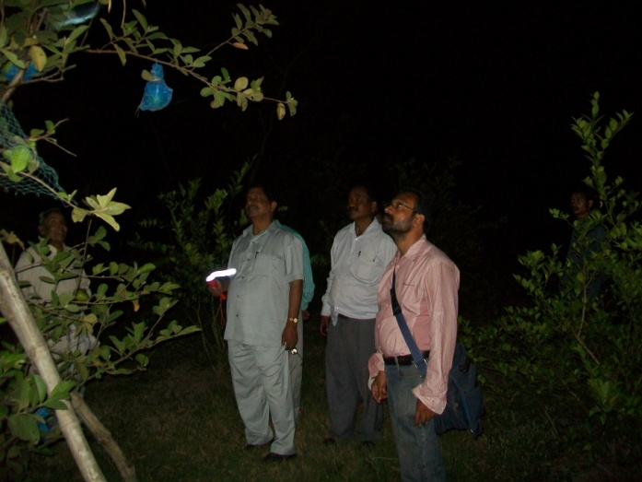
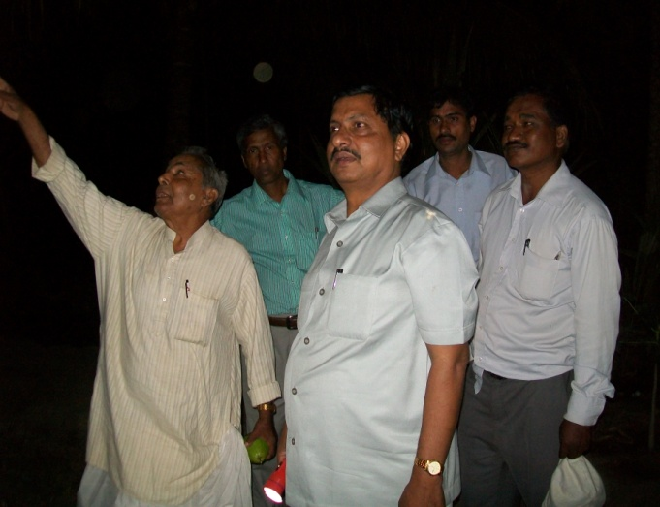
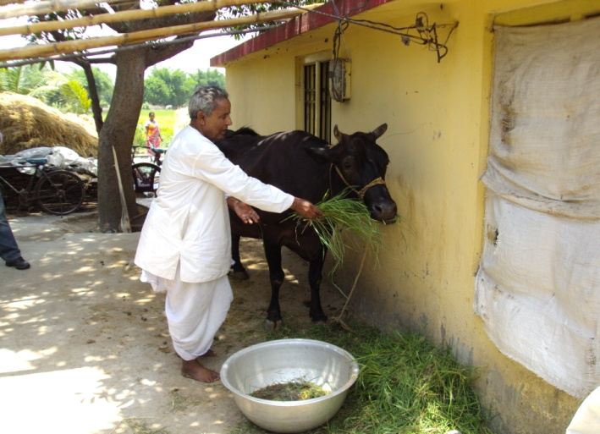

VERMI UNIT; MINOR ATTENTION AND MAJOR PROFIT
Sri Ananta Kumar Jena, a progressive farmer of Kushadiha village in Baliapal block of Balasore district is an entrepreneur in producing vermi culture. After experiencing repeated decreased production in HYV paddy and attending KVK training, he came to know the role of FYM & bio-compost for maintenance of soil conditions. He searched for good quality compost and FYM which was in short supply. He approached KVK, Balasore for technical assistance and learnt vermi composting as an effective source of quality bio-compost.
Sri Jena then constructed 2 vermi compost tank of 7’X6’X2.5’ one each and a vermi hatchery of 3m x 1.5m x 0.09m per tank. From the tanks he got annual production of 3.6t vermi compost and 60kg of earthworm in a year. The cost of vermi compost was Rs. 18,000/- and that of 60kg of earthworm was Rs. 30,000/- @ Rs. 500/kg. His total expenditure was Rs. 12,500/- in the construction & maintenance thus yielding a net return of (18,000+30,000)-12,500/- Rs. 35,500/- per year. He has became a reference person in earthworm cultivation & vermi composting in Baliapal, Jaleswar & Bhograi blocks by supplying vermi worm cum composting knowledge to the young entrepreneurs. Twenty women of 2 women SHGs have started vermi composting at his efforts.
Apart from monetary return, his paddy yield has increased by 34% through SRI method of Ranidhan, 16% in vegetable like ginger, turmeric, brinjal, chilli & cucumber thus enhancing his income. He has found an increase in keeping quality of his produces with low cost of production due to improved soil texture/structure by application of vermi composts. Sri Jena is an innovator in experimenting profit maximization from agro entrepreneurship, making vermi culture, a commercial cum income earning venture as well as providing quality earthworms and vermi composting technique to the peer farmers of Balasore district in general & north Balasore in particular.
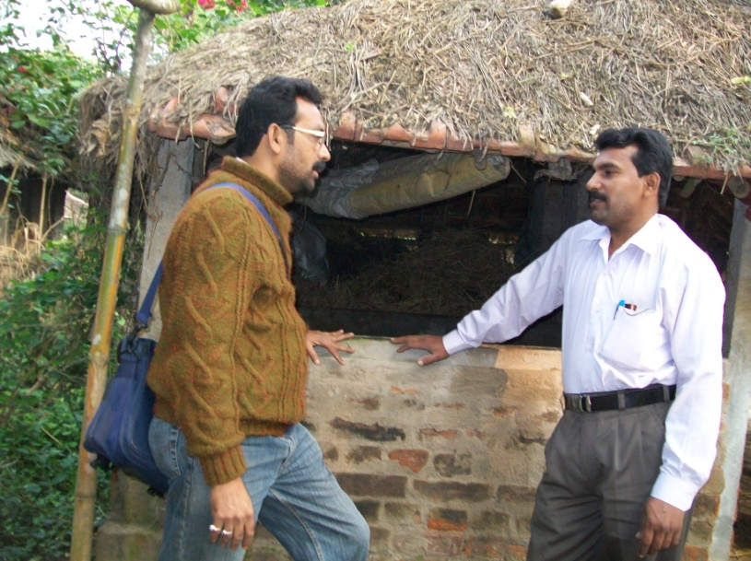
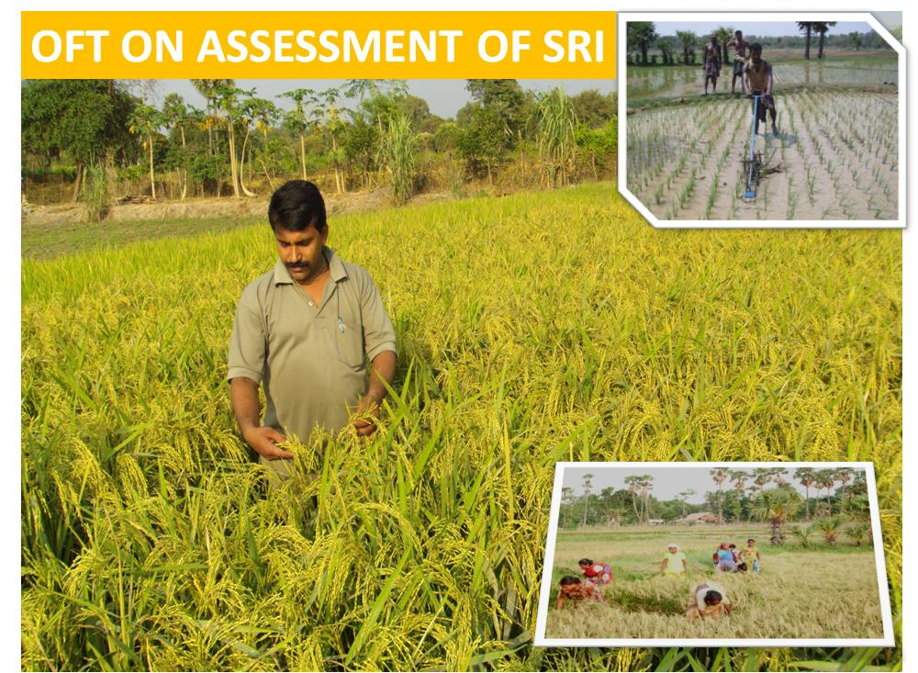
.
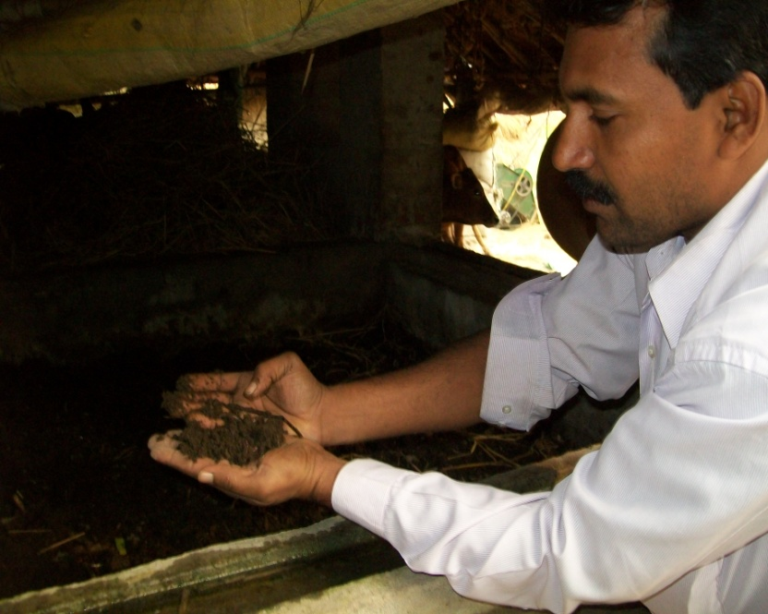
SRI Method of paddy cultivation

